TEAM ID:PNT2022TMID28841

PROJECT NAME: DemandEst - AI powered Food DemandForecaster

Team Leader

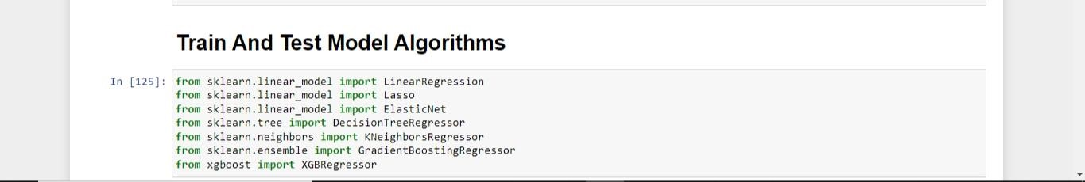

Team Member 1



Team Member 2



Team Member 3

